1. Liability Disclaimer
PENETRATION TESTING REPORT
FOOTPRINTING & NETWORK SCANNING PHASES
W2-PM-FINAL | CYBERSECURITY | NETWORKWALKS

Pentester Name  (Cybersecurity Professional) | Iyaloo Shivute
Program/Batch | B082-Networkwalks
Date | 23 August 2026
Modules completed | W2-PM1 (Multiple Kali Tools)  W2-PM5 (Zenmap Scanning)
Client/Target | 1. Networkwalks (secured written permission already)  2. My own local LAN Network
Permission secured from client? | Yes
Phases covered | Phase 1: Reconnaissance & Footprinting  Phase 2: Scanning & Network Discovery  Phase 3-5: In Progress

I have performed these activities only on the systems & devices where I had secured written permission and, on the devices/systems that I own myself. All these materials are for education and research purpose only. Do not use anything from here to break the law. The instructor, the authors and Networkwalks are not responsible for what you do with this knowledge. Every action you take is your own responsibility. Misuse can lead to criminal charges, heavy fines, loss of your job and a permanent record. In most countries unauthorised access is a crime even when nothing is damaged.

2. Introduction

This report, which is the second week of my ongoing internship program at Networkwalks, covers reconnaissance and footprinting of the networkwalks.com domain using multiple Kali Linux tools (W2-PM1) as well as scanning my own local network with Zenmap (W2-PM5). The first module covers the footprinting phase while the fifth covers the scanning phase, so taken together they show how an attacker moves from gathering public information to mapping live hosts on a network.

Commands were executed on a Windows computer running Zenmap for scanning and under Kali Linux for footprinting. Each step listed below contains the precise command used, the outcomes, screenshots as proofs, and a brief explanation of why the discovery is significant from the perspective of an attacker.

3. Tools Utilized
The tools used and their functions are listed in the table below.
Tool | Function/Purpose
Kali Linux & Windows | Operating systems used for reconnaissance activities
WHOIS | Find domain registration details (owner, dates, name servers).
whatweb | Fingerprint web technologies (server, CMS, plugins, Frameworks and IP address).
nslookup | Resolve the domain name to its IP address using DNS.
curl -I | Read the HTTP response headers of the website.
wafw00f | Detect whether a Web Application Firewall is protecting the target site.
dnsrecon | Enumerate all DNS records (NS, MX, SPF, TXT, SRV).
Zenmap (Nmap GUI) | Scan the local subnet to find live hosts, IPs and MAC addresses.
Windows CMD | Local IP and MAC address identification

4. Activities Performed

4.1 Footprinting & Reconnaissance

Using six Kali Linux tools namely: WHOIS, WhatWeb, Nslookup, Curl, Wafw00f, and DNSRecon, I conducted reconnaissance against the networkwalks.com domain. A complete profile of the target was created by combining the different types of information that each tool gathered.

TASK 1: I identified the domain's name servers and obtained publicly accessible domain registration information using WHOIS. The outcomes provided details regarding the hosting infrastructure and domain registration.

TASK 2: I used WhatWeb to fingerprint the technologies running on the website. WordPress 7.1 and WP Download Manager 3.3.58 were found in the results, along with other information that the website exposes.
TASK 3: I was able to translate the domain name to its IP address using Nslookup. The provided result identified 192.232.216.135.
TASK 4: I examined the HTTP response headers using Curl with the -I option, which revealed more details about the web application and exposed the WordPress REST API endpoint /wp- json/.
TASK 5: To find out if the target website was protected by a Web Application Firewall, I utilized Wafw00f. ModSecurity (SpiderLabs) WAF was found in the outcome.
TASK 6: I enumerated all DNS records using DNSRecon. The findings included details about DNS software, SPF/TXT records, mail servers, name servers, and service records.

4.2 Network Scanning with Zenmap
For this exercise, I performed network discovery on my local network using Zenmap. I had to find active hosts, determine their IP and MAC addresses, determine my local IP address and subnet, and create a network topology as part of the practical.
I identified my local IP address and LAN subnet using the Windows ipconfig command. In order to find active hosts, I thereafter input the subnet into Zenmap and chose Ping Scan.
I found two hosts live in my subnet with following IP addresses; I then used ipconfig /all to find their MAC addresses.
- 172.20.10.1
- 172.20.10.2

After completing the scan, I opened the Topology section in Zenmap, enabled the legend and saved the network topology in PDF format as required by the practical exercise.

5. Risk Analysis / Impact
I identified the following potential risks based on the data gathered during the network scanning and footprinting activities.
# | Risk / Finding | Evidence / Observation | Potential Impact | Risk Level
1 | Web technology information exposed | WhatWeb identified WordPress and WP Download Manager | An attacker looks these versions up in vulnerability databases to find known exploits. Attackers may use exposed technology/version information to identify software requiring further security review. | ● Medium
2 | Server IP address identifiable | Nslookup resolved the domain to 192.232.216.135 | Provides information about the network location of the web service. An attacker can map the target's architecture, search for other sites on the same IP, and directly scan the server if they know the IP. | ● Low
3 | HTTP technical information exposed | Curl returned HTTP response headers and exposed /wp-json/ | May assist technology fingerprinting and further enumeration | ● Low
4 | WAF technology identifiable | Wafw00f identified ModSecurity (SpiderLabs) | Revealed information about the web application’s security architecture. | ● Low
5 | DNS infrastructure information exposed | DNSRecon identified DNS, mail and service-related records | DNS information can help build a broader infrastructure profile. Each record is a potential foothold and helps an attacker understand the email and hosting setup. | ● Medium
6 | Live hosts visible on local network | Zenmap identified two live hosts in my subnet. | Unknown or unauthorized devices may potentially be present on a network | ● Medium

Risk level key: ● Critical ● Medium ● Low
The risks listed above are not confirmed vulnerabilities; rather, they represent observations from the scanning and footprinting exercises.
Information gathering and host discovery were the main tasks of the practical exercises. These two modules did not include any exploitation or vulnerability validation.
Thus, the existence of data like an IP address, DNS record, or software version does not automatically indicate that the system is vulnerable. Therefore, actual vulnerability would need to be confirmed by performing additional authorized security testing.

6. Recommendations
I recommend the following security enhancements considering the observations made during these activities:
- Review publicly exposed technology information
Networkwalks should periodically assess what data is accessible to the public on its web technologies, content management system (CMS), and plugins.
- Keep software updated
Regular updates and reviews against the most recent security alerts are necessary for CMS, plugins, and other web technologies.
- Review HTTP headers
To find out if unnecessary technical information is being exposed, HTTP response headers should be inspected.
- Review DNS records regularly
To make sure that only necessary data and services are made available to the public, DNS records should be frequently examined.
- Properly configure and monitor the WAF
Since WAF ModSecurity (SpiderLabs) currently prevents naive attacks, it should be kept enabled and tuned.
- Perform regular internal network discovery
To find active devices, organizations should regularly scan their own networks.
- Investigate unknown devices
Any unusual device discovered during network scanning should be investigated and verified.
- Maintain network documentation
Network topology and device information should be documented and updated regularly.
- Conduct authorization-based security testing
Only when proper permission has been granted should reconnaissance and scanning be performed against systems and networks.

7. Conclusion
In the second week of my internship in cybersecurity and ethical hacking, I completed hands-on exercises in network scanning, reconnaissance, and footprinting.
I gathered data on the target domain using six Kali Linux tools during the footprinting exercise. I also discovered that DNSRecon can provide more DNS information, Wafw00f can detect a WAF, WhatWeb can identify web technologies, Nslookup can resolve domain names, Curl can examine HTTP headers, and WHOIS can provide domain information.

During the network scanning exercise, I used Zenmap to find active hosts and identify my local network settings. In addition, I gathered IP and MAC addresses and made a network topology.
I learned from the exercises how crucial information collection is to cybersecurity. By closely examining publicly available data and network responses, a security professional can learn a great deal about an environment even before attempting to exploit a system.

I also learned the importance of clearly documenting technical discoveries. Additionally, a sound cybersecurity report should include what was done, what was found, the significance of the observation, the potential danger it poses, and how to mitigate such risks. In summary, I learned that reconnaissance is powerful and very hard to detect. Moreover, fooprinting and scanning must always be performed within an authorized scope.

8. Evidence Gathered
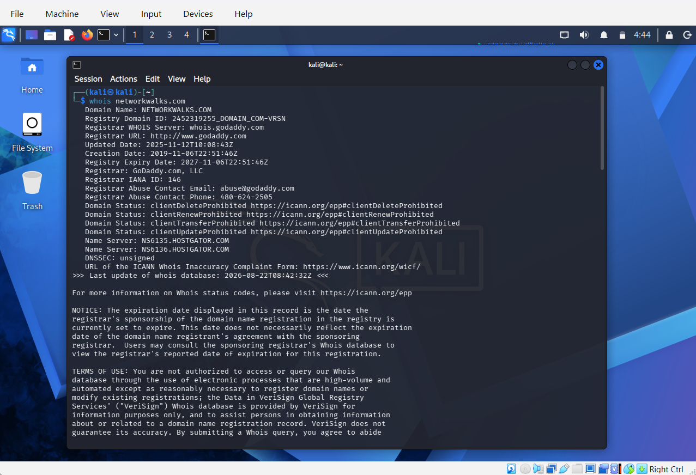
Figure 1: whoisnetworkwalks.com

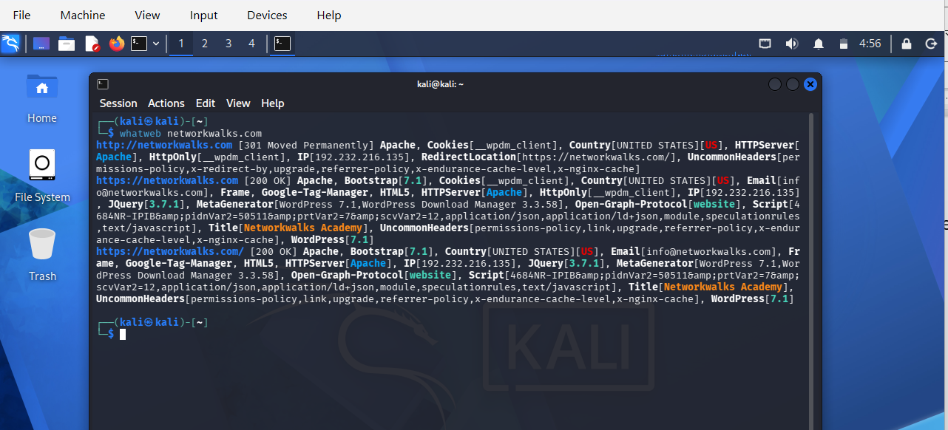
Figure 2: whatweb networkwalks.com

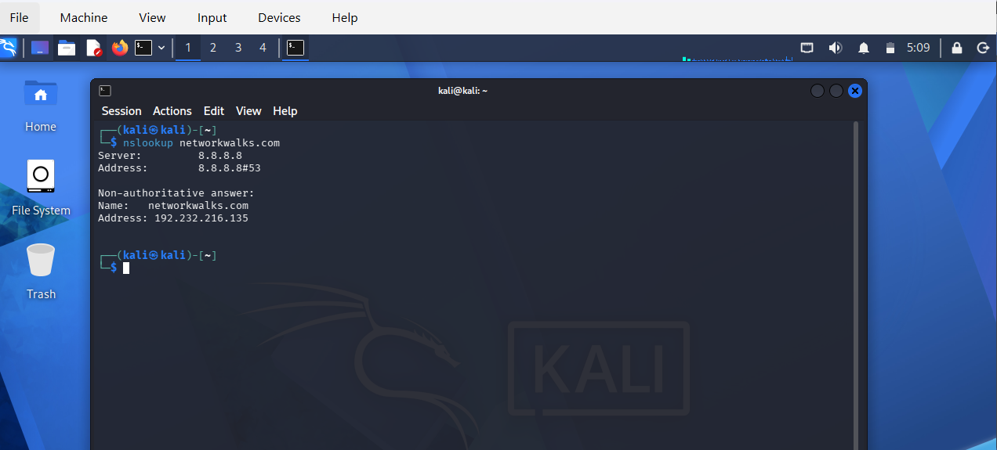
Figure 3: nslookup networkwalks.com

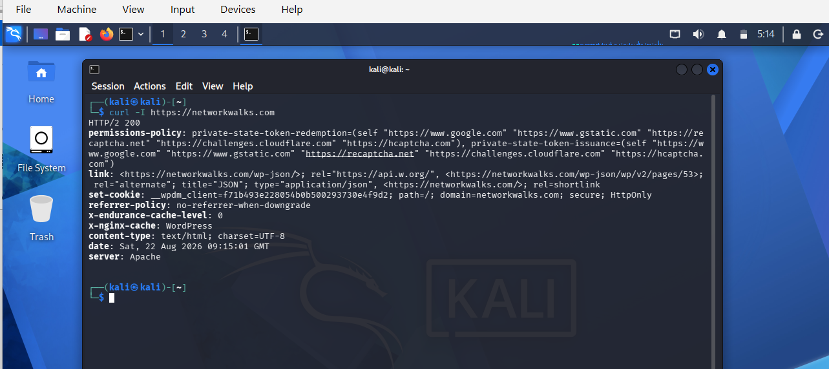
Figure 4: curl -I https://networkwalks.com

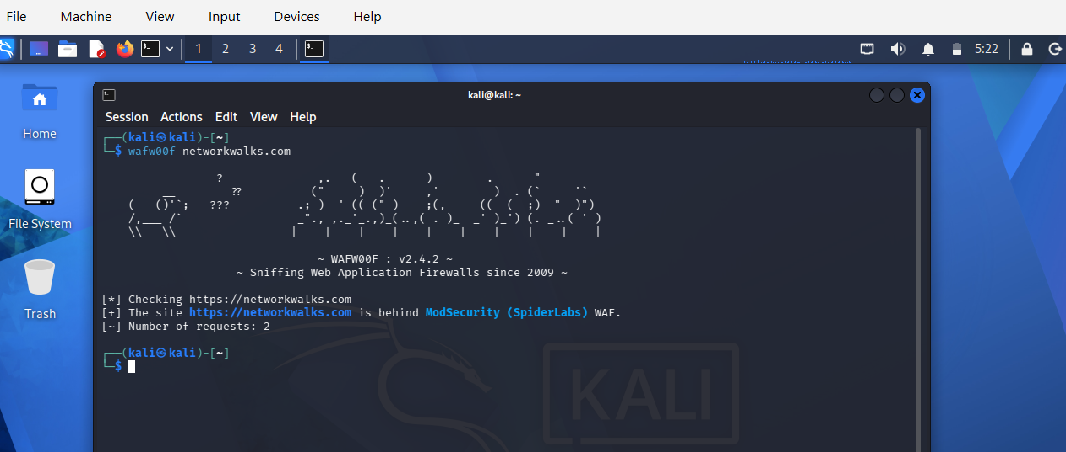
Figure 5: wafw00f networkwalks.com

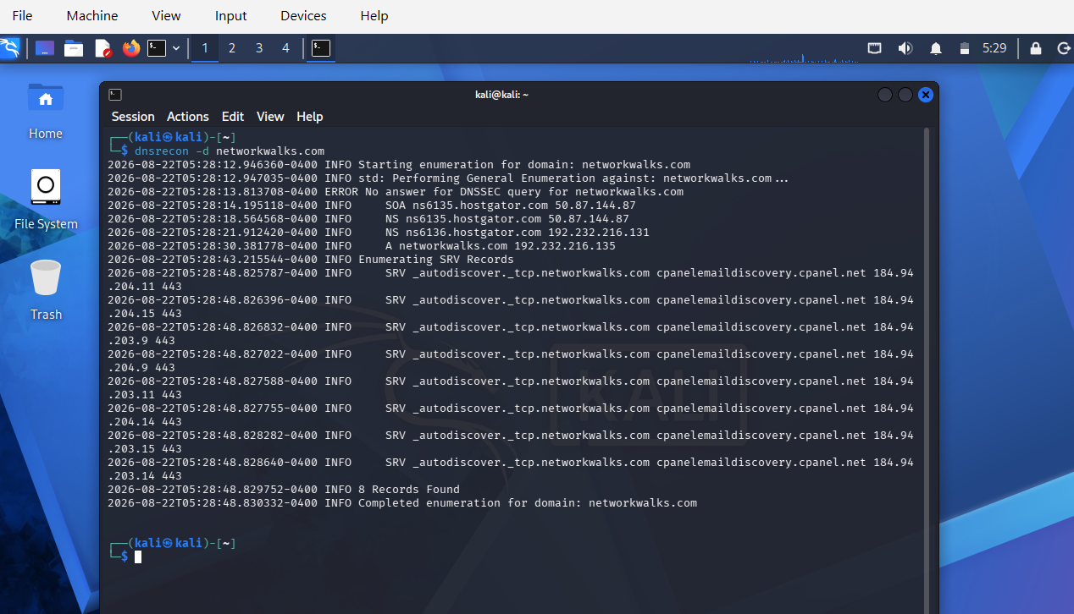
Figure 6: dnsrecon -d networkwalks.com

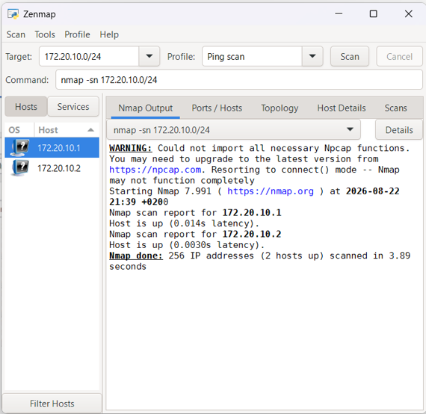
Figure 7: Live hosts - Ping Scan

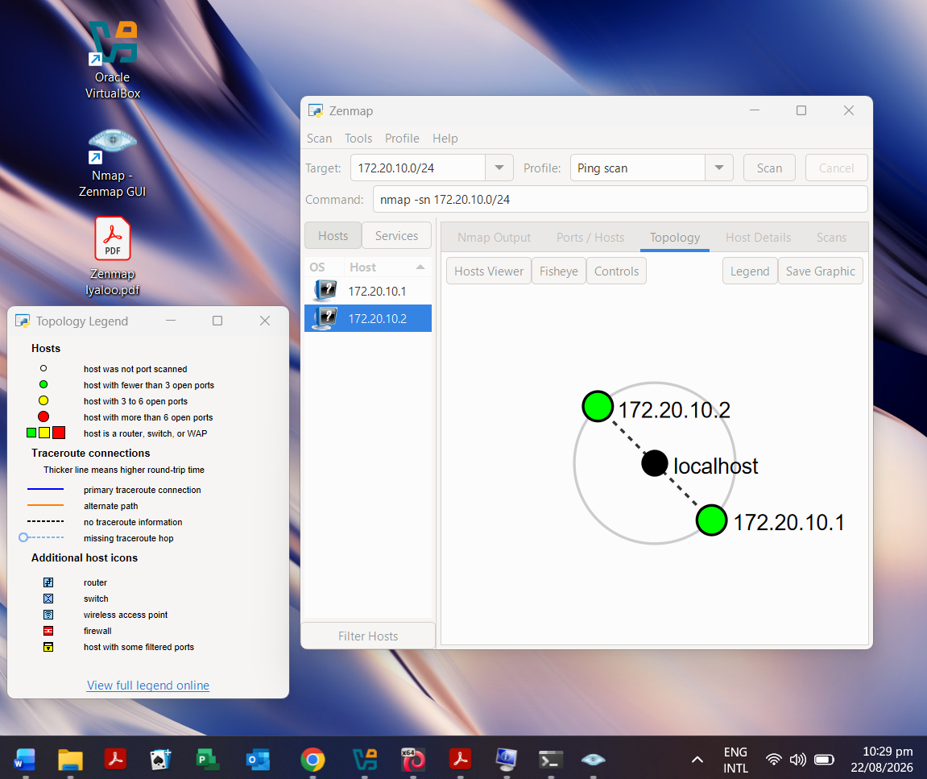
Figure 7: Legend details, and Network Topology

~~~~~~~~~~~~~~~~~~~~~~~~~~~~~~~~~~~~~END~~~~~~~~~~~~~~~~~~~~~~~~~~~~~~~~~~~~~

👤 Author
Iyaloo Shivute
Cybersecurity Intern B082
LinkedIn: www.linkedin.com/in/iyaloo-shivute

📌 Project Information
Program Name: Cybersecurity program at Networkwalks | Week: 02 | Repository: GitHub

